Adventure

The beauty was often accompanied by the hardship of the journey, full of unexpected changes of plan and real mishaps
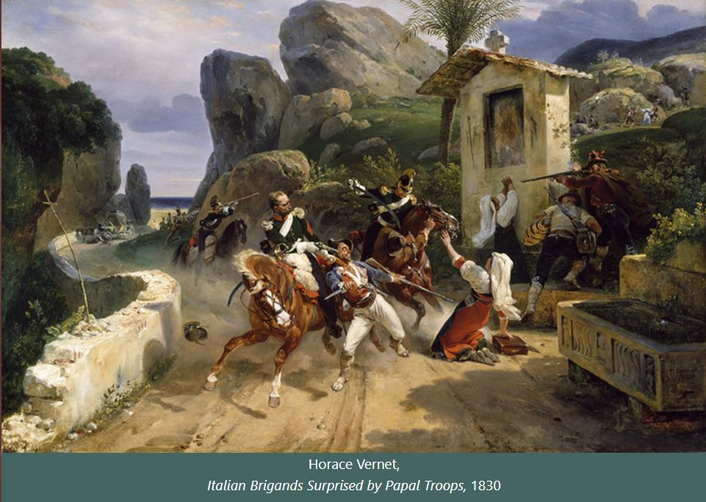

The trip to Italy was an unforgettable adventure. Not only for the richness and beauty of the monuments; for the wonder of the towns and villages in this extraordinary widespread museum; for the splendour of the landscapes, the mildness of the climate and the pleasure of living; but it was also an unforgettable adventure because of the unforeseen events and mishaps along the way. I remember the carriage that took me from Moncenisio to Turin: it had aching suspensions and the road was all dust and bumps. At the frontier the formalities were never-ending and I had to endure the sulphurous fumes prescribed by hygiene regulations. However, I avoided quarantine and, above all, the brigands who were really terrible in the areas of the Pope and the Kingdom of Naples.

Collectors

The travel experience of the Connoisseur must include the collection of works of art to be brought back home

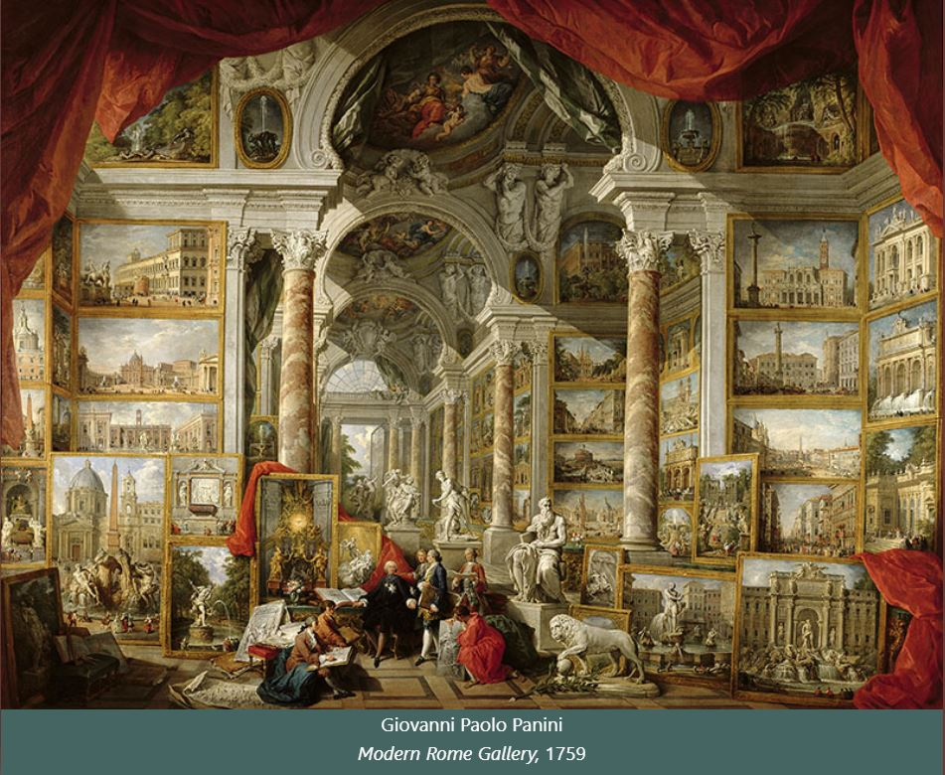

Travellers were often also insatiable collectors and loved capricci. Architectural and pictorial capricci, of course, where fiction exceeds reality. The most celebrated painter, at the time of my first trip to Rome, was Giovanni Paolo Panini from Piacenza, who painted wonderful, dreamy, imaginary views around mid-century. As a professor of perspective at the prestigious Academy of France, Panini knew very influential collectors, such as the Duke of Choiseul for whom he painted two 'squared' pictures where some characters are overlapped by a monumental picture gallery. Ancient Rome represents an imaginary basilica containing paintings depicting architecture and statues of ancient Rome. Modern Rome is an immense aisle on whose walls hang reproductions of Baroque buildings and statues, including Michelangelo's Moses.
Naming the paintings has always been a fun game for me.

Eternal Roma

Rome, the main destination of Grand Tour

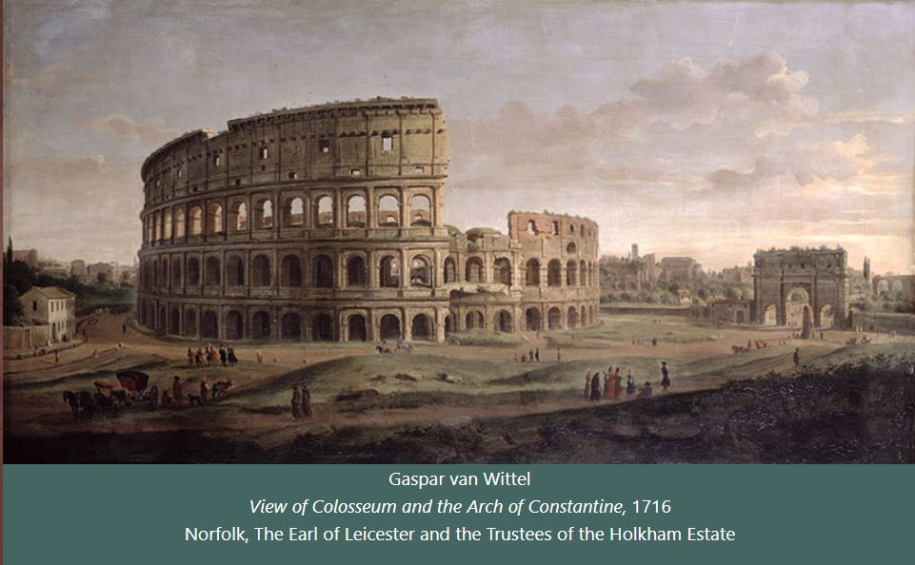

Entering the Eternal City from Porta Flaminia for the first time, I felt a very strong emotion. Rome! The capital of antiquity, the holy city of Christianity, the city where ancient ruins everywhere remind me of lost greatness, opened up before my eyes. Over the centuries the Caput Mundi had become a museum city, a village of 150,000 inhabitants dotted with ancient remains and wonderful baroque illusions. I didn't sleep that night and the next morning, as if I were a conqueror from another era, a barbaric collector of emotions, I stepped firmly into the ruins of the Roman Forum. The places where Romulus had stood, Cicero had spoken and Caesar had fallen under the dagger of the conspirators, stood before me with overwhelming power. It was only after an uncontrollable euphoria, a fever that lasted several days, that I began to observe these vestiges with a more careful and measured eye. A clear picture was painted in my mind, a fresco where the ruins shone with ancient light.

Phenomena & Prodigies

The charm of the 'sterminator Vesevo', a fatal attraction for artists, scholars and travellers
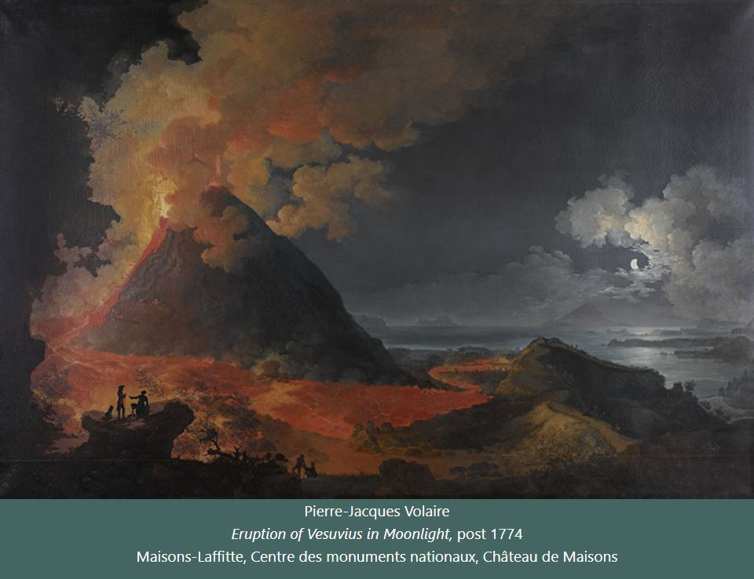

In Naples, I had the good fortune to witness one of nature's most terrifying manifestations. It was in 1785. From a privileged observatory, I watched the river of fire descending from the mouth of Vesuvius towards the gulf and was pervaded by contrasting emotions: terror and redemption. As if the sublime and the terrible coexisted in that grandiose, unrepeatable vision. I understood then why Vulcano's great workshop had become an icon for all those travellers who wanted to bring back an intangible souvenir of Naples. As I followed the eruption with morbid curiosity, I was struck by the meticulousness and calm of my host Lord Hamilton, the English ambassador, a great lover of antiquities and volcanology. He was taking notes for a report to be sent to London, to the Scientific Society of which he was a member. Under the volcano, material life pulsated and cultural life meditated.

Goethe & Madame de Stael

The emblematic Journey in Italy between Enlightenment and Romanticism
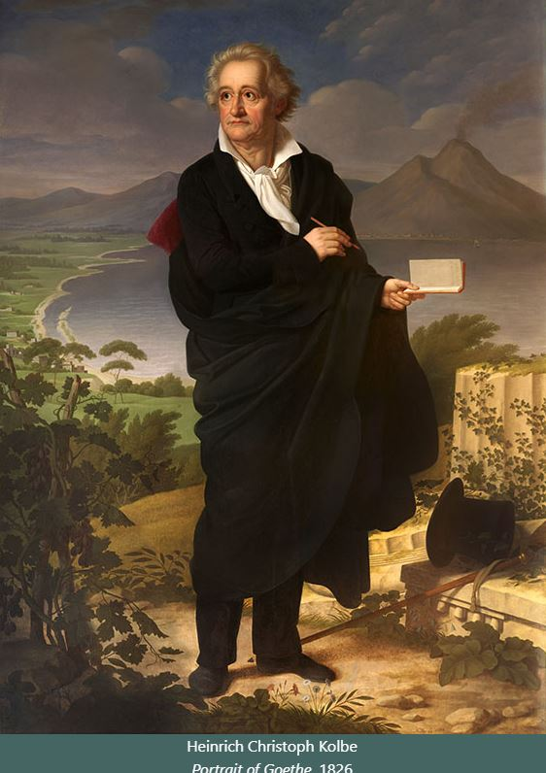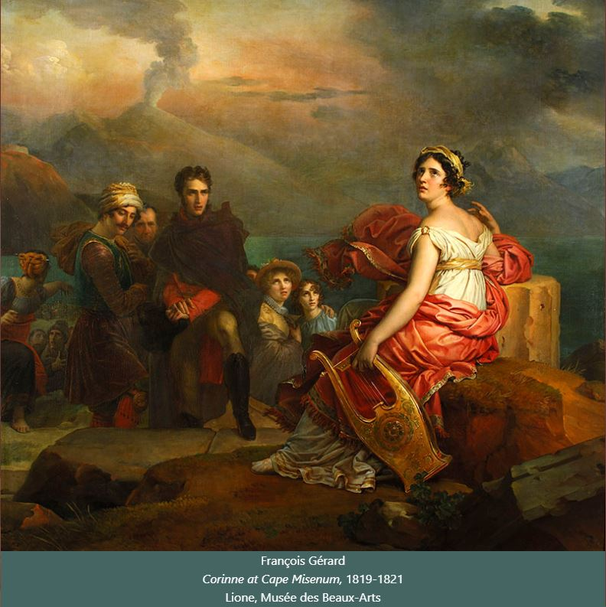

To prepare for my second trip to Italy, I read Italienische Reise, a book about the Grand Tour, written by Goethe.
No one has been able to convey the fascination of Italy to the reader like the great German writer. Goethe considered those two years spent in Italy to be the happiest of his life. Reaching the land of his dreams meant rediscovering the sources of his lost inspiration.
Vicenza, Rome, Naples and finally Sicily, the island that engraves an unforgettable image in the soul of travellers. However, it was a novel from 1807, translated into all languages, Corinne ou l'Italie, that carved into the romantic imagination of the 'bel paese ch'Appennin parte e 'l maronda et l'Alpe' - as Petrarch wrote. The author, Madame de Staël, tells of the unhappy love between a Roman poetess of English origin and Lord Nelvil, a Scottish Puritan nobleman.

Italy

The political and economic situation in Italy at the turn of the 18th and 19th centuries

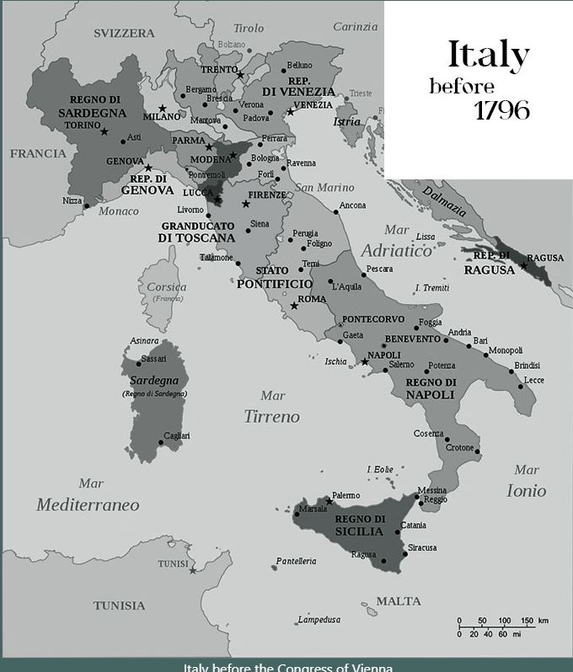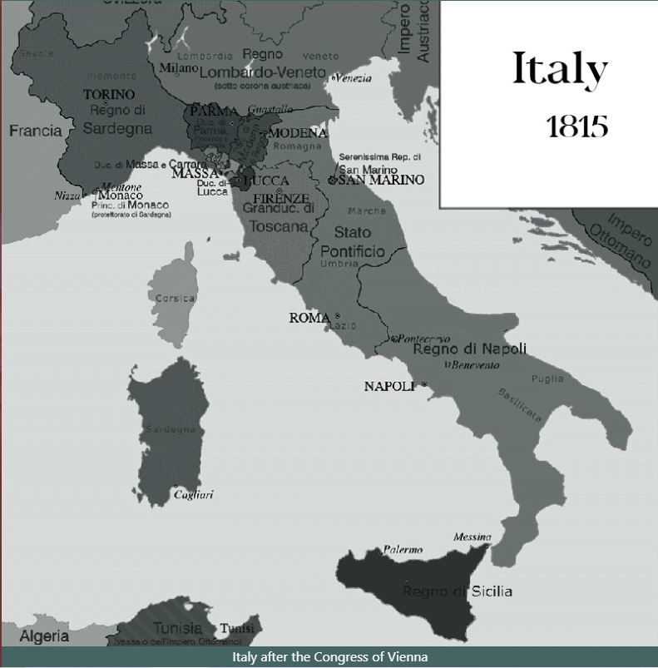

On my second trip to Italy, I found a country profoundly changed. In the land of dreams, adventure and history, in the cities where art and beauty, light, calm and voluptuousness reigned, the restlessness of the innovators was felt everywhere. The idea of restoring a single, unified name to this garden of wonders was gaining ground. The Pope and all the deposed sovereigns were back on the throne. But while Austria supervised the new order in Vienna - and punished offenders - the romantic spark of independence smouldered under the ashes of absolutism. It was as if a spell had been permanently broken.
It was with great sorrow that I discovered that the Most Serene Republic of Venice and the Noble Republic of Genoa, erased from the new map of power, were lost forever, and with them two vital centres of art and culture for the whole of Europe.

Mirabilia

History, art, culture and cosmopolitan liveliness of the Neapolitan scene
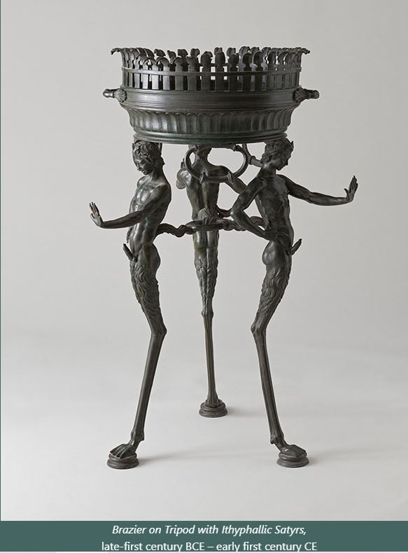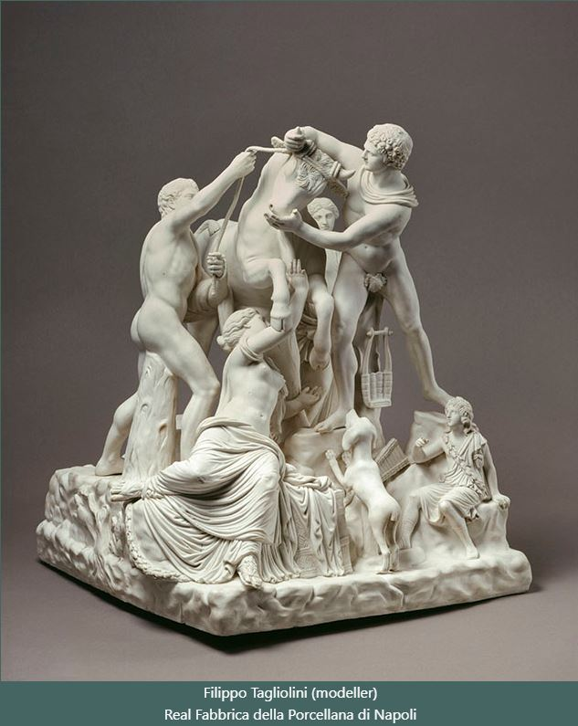

From Rome I decided to go to Naples, not only to admire the beautiful landscape and the voluptuous calm of the Gulf, but above all to visit the excavations of Herculaneum and Pompeii, which had just been discovered, and the Doric temples that had emerged from the reclaimed plain of Paestum. In Pompeii, what intrigued me most were the minor objects of everyday life. Artefacts that had been buried for 17 centuries suddenly came to light in the Age of Enlightenment. Antiquarians, craftsmen and men of letters flocked to excavate, to study and to copy the works that Charles III of Bourbon had collected in the Portici museum. Furnishings, furniture, decorations, gems and wonders of all kinds became the ideal models for cabinet-makers, ceramists and goldsmiths, who offered all kinds of souvenirs to travellers. The hunger for classicism was insatiable.

Nature

The variety of Italian territories provided unforgettable sets
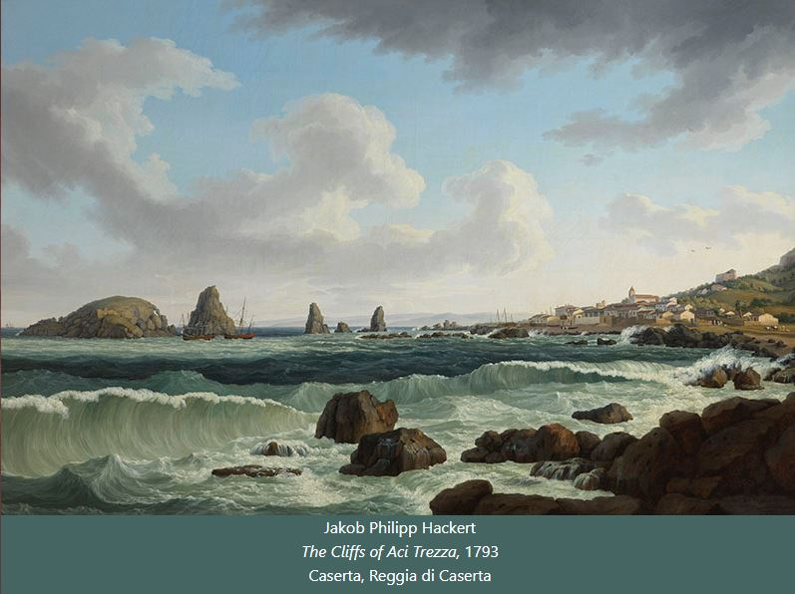

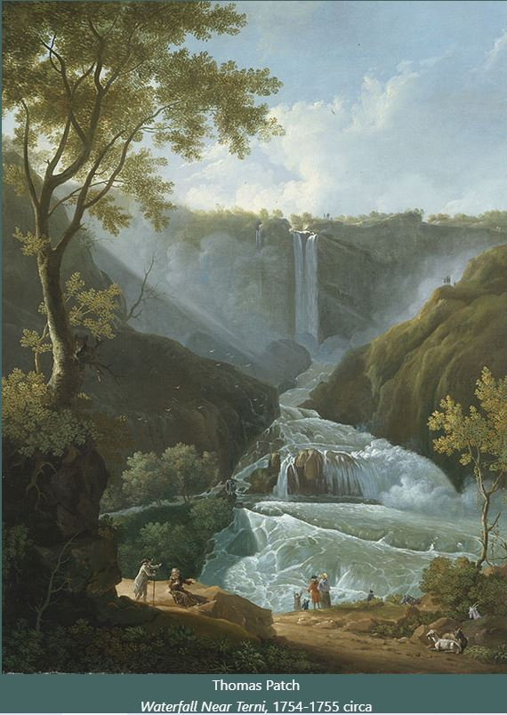 | The exuberant nature of Italy was a favourite subject for artists. Especially foreign artists who found insatiable inspiration in the evocative power of the Italian landscape. Views pervaded by an ideal light, wonders, made optically more persuasive than reality itself. The observation of nature and its most extreme manifestations satisfied both the spectacular aims capable of arousing the feeling of the sublime, and the scientific theories linked to the recent discoveries in optics. Waterfalls, tidal waves and eruptions perfectly interpreted the cosmic power of Nature.  Natural phenomena found a moving exaltation in these works.

Landscapes

Landscape as a cognitive and sentimental experience
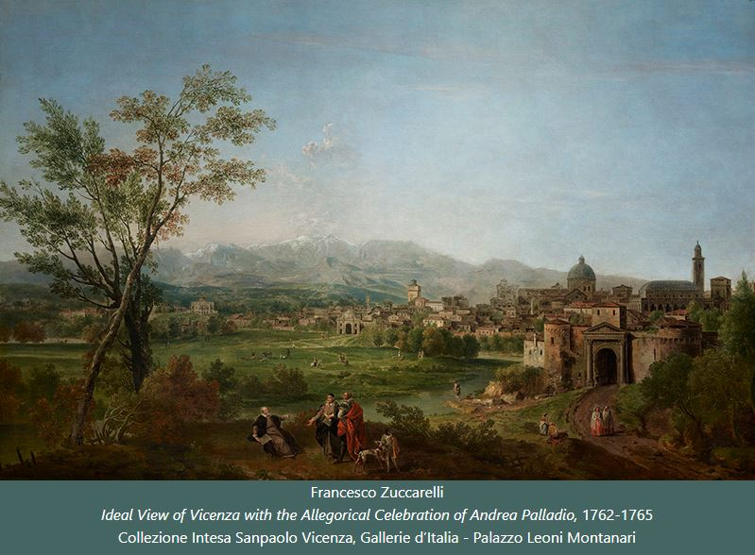

The demands of foreign collectors considerably broadened the horizons of genres such as views and landscapes. Never before had the pictorial repertoire been so broadly expanded under the pressure of new aesthetic categories such as the picturesque and the sublime. The variety of soils, stones, rocks, valleys and trees was compared with the sumptuousness of ancient and modern buildings. Rustic farmhouses and stately villas, the ruins of monuments and ancient trees were set against powerful backdrops of waters and streams, springs, rivers, lakes, seas with views of ships and rocks. The views were studied from life and then finished in the studio following the dictates of the new techniques.
The landscape became a spectacle on which to reflect and meditate, especially at dawn and dusk.

Portraits

Pompeo Batoni, the Prince of Italian portraitists
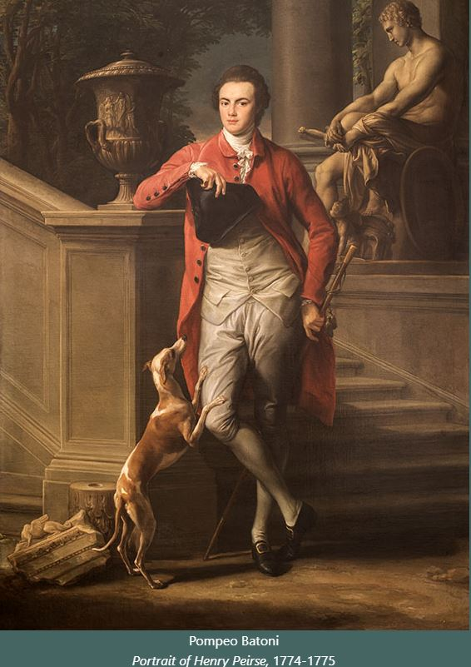

When I thought of placing my effigy among ancient remains in the background, I turned to the greatest interpreter of this genre. Pompeo Batoni, an established figure painter, but also the author of fine sacred, mythological and allegorical subjects, was happy to oblige. In Rome, Batoni had gained international fame thanks to an absolutely competitive formula, in relation to the quality of the results. In essence, he was much less expensive than his English colleagues, such as Reynolds. Venality aside, I liked the way he depicted his high-ranking clients in elegant poses against a backdrop of classical masterpieces. Inevitable in every portrait is the dog, depicted with unparalleled skill as a faithful friend, accompanying his master on his travels.

Serenissima

The events, ceremonies, shows and festivals of the Republic of Venice
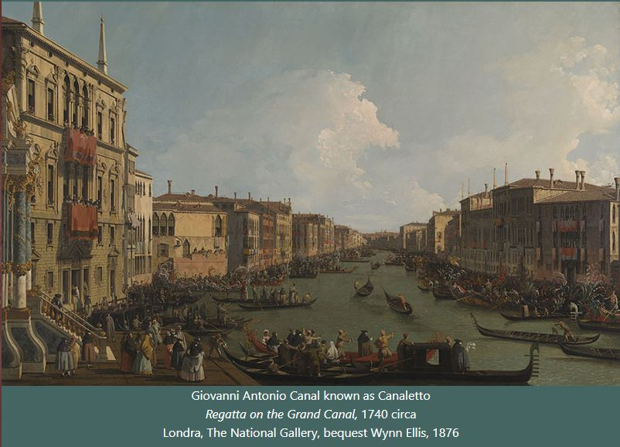

Instead of the usual carriage ride from Bologna, I preferred to travel to Venice by burchiello along the waterways. The journey on this elegant river boat with its finely decorated cabin adorned with mirrors, views and precious carvings took almost a day from Padua to Venice, But I was rewarded because on the way I got to see the enchanting villas of the Riviera del Brenta. La Serenissima was the final destination of my Grand Tour of Italy. Then I would cross the Alps and return to England. The Venetian archives contain endless lists of travellers, of all nationalities, attracted by the uniqueness and splendour of this city on the water. It is an ever-popular venue for social occasions, spectacular public festivals and grandiose historical liturgies, somewhere between a religious rite and a commemoration of seafaring power. On Ascension Day, the ceremony of the Marriage to the Sea is celebrated, in which the splendour of the ancient Republic is celebrated by the entire population. The regattas in which the sestieri challenge each other in a race to prepare the crews of the battleships are also very enjoyable.

Uffizi

The great collection of Medici antiquities in the Uffizi Gallery

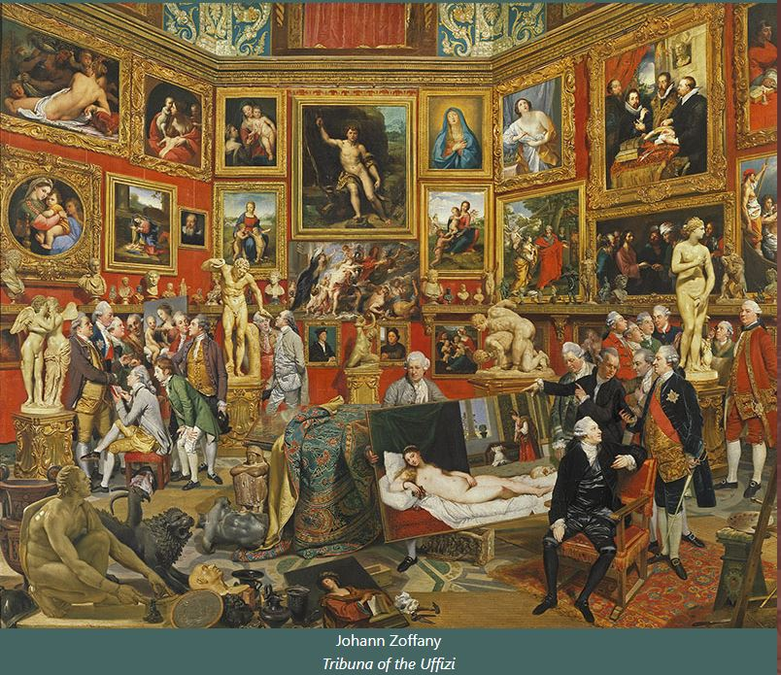

A visit to the Uffizi Gallery gave me the opportunity to converse with the ancient statues of marble perfection, surrounded and almost overwhelmed by the pictorial masterpieces of the greatest masters of the Renaissance. The Uffizi was an obligatory stop in Florence, especially for collectors, mainly English, who had the opportunity to admire and comment on such wonders. In the same hall, the main masterpieces of the Medici collection were arranged with great scenographic skill. The painter Johann Zoffàny made a celebrated representation of them, showing the famous knife-grinder and the statuesque Venus in the foreground at the sides, with Titian's Venus in the centre. Among the characters crowding the painting is the author himself as he shows a work by Raphael to an esteemed collector who intends to give it to the King of England. The Lord, whose name I shall not mention, hoped to obtain with this gift a title of nobility appropriate to his growing ambitions

Vestigy

The traces of an idealised and vague antiquity coexist with the landscape, giving life to caprice as a source of artistic and cultural inspiration
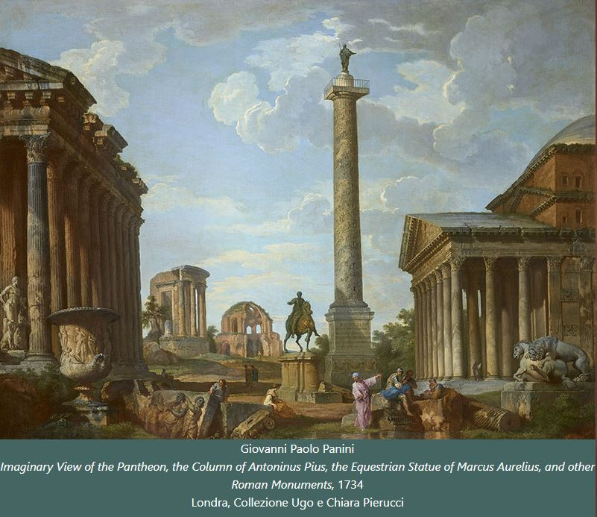

When I first saw a capriccio I was literally enraptured by the expressive power of these pictorial inventions, where the taste for the antique reaches its apotheosis. Those simultaneous views of several monuments in a single painting fascinated me. I never tired of looking at them: observing, recognising and fantasising. With experience I began to distinguish the different modes of 'pictorial whimsy'. In some authors, real monuments are mixed with imaginary ruins; in others, an archaeological and documentary intent prevails in the representation of monuments. Others are pervaded by an elegiac atmosphere that arouses a feeling of nostalgia and regret for a lost past.

Winckelmann

The canon of Greek and Roman classicism
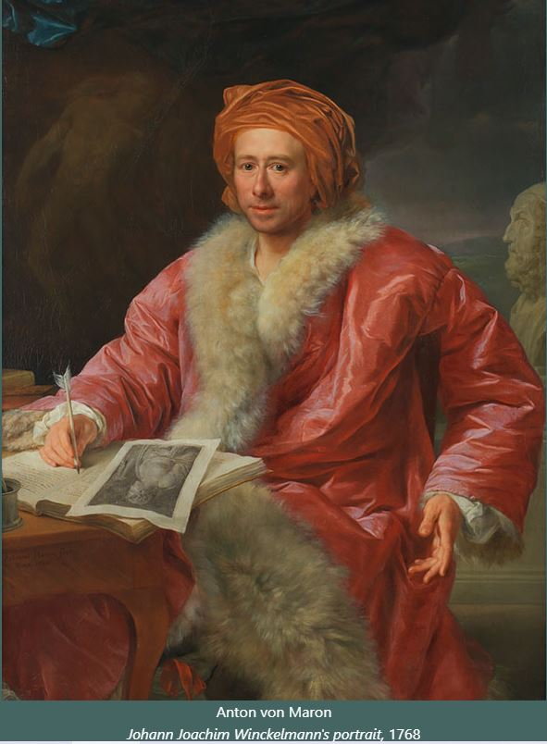

Admiring the princely collections of the Roman families: the Colonna, the Massimo, the Orsini Visiting the galleries of the descendants of the popes: the Chigi, the Pamphilj, the Corsini, the Borghese was a unique experience. A continuous emotion that left me breathless. It was wonderful to be in the presence of the masterpieces that had fixed the canons of ideal beauty forever. That beauty theorised by Johann Winckelmann, the great 'inventor' of neoclassicism, whom I was lucky enough to meet in person in Rome. During my visits to the Roman collections, it was he who was my guide. Winckelmann was later appointed librarian and curator of the works of Cardinal Alessandro Albani, in the large villa on the Via Salaria, which had passed into the hands of the Torloni family. That refined and skilful display of works of art became a model for many princely galleries throughout Europe and of course in England too.

Zarevic

The undercover journey of the Northern Counts
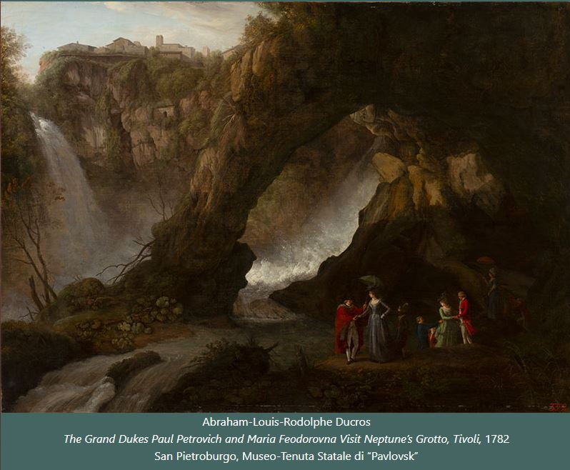

In Venice, I was invited to the sumptuous dinner in honour of the Counts of the North, for whom, you can imagine, the Carnival was even brought forward. The San Beneto theatre was packed with dignitaries and courtiers. Behind that charming pseudonym - Counts of the North - travelled incognito the Grand Duke Paul Romanov, the future Tsar, and his wife, the Grand Duchess Maria Fyodorovna. Zarevic was twenty-seven years old, spoke fluent French and German and a few words of English. Mathematics, physics, astronomy, navigation and architecture were among his main interests. He was also a decent painter and enjoyed good music. In short, a true gentleman. I had already met the noble couple in Rome at the studio of the painter Ducros, from whom they were commissioning paintings as souvenirs of their trip to Italy, and they brought back many souvenirs and works of art. Young and inexperienced, they did not leave any tips when they passed through and were severely judged by the Venetian merchants. In reality they simply did not know the local customs.

