TEST – multiple choice (with links)
Sometimes more than one option is possible

1
Instead of saying “I’M COMING” you can say:
- I am with you.
- I am on my way.
- I am jumping.
https://www.instagram.com/p/CiKLHbTJ4Y5/

2
Instead of saying “LET’S GO TO THE GYM” you can say:
- Let’s hit the gym.
- Let’s smash the gym.
- Let’s eat the gym.
- Let’s swing the gym.
https://www.instagram.com/p/Cevtwe1sxbA/

3
Instead of saying “I’M GOING TO THE BEACH” you can say:
- I’m headed to the beach.
- I’m pointing to the beach.
- I’m firing to the beach
https://www.instagram.com/p/ChEg0B6vI-7/

4
Come si dice in inglese “Ho il telefono scarico”?
- My phone is empty
- My phone is drain
- My phone is out of battery
- My phone’s dead
https://www.instagram.com/p/Cg_eG8Wu3cY/

5
Come si dice in inglese “Fa caldissimo”?
…………………………………………………………..…………………………………………………………………………..
https://www.instagram.com/p/CgjNLVJuS3M/

E come diresti “Fa freddissimo”? ………………………………………………………………………………………
Conosci l’espressione “Cold enough to chill my bones”!! usata dai Maroon 5 nella loro ultima canzone? –secondo te cosa si intende?
…………………………………………………………..…………………………………………………………………………..
https://www.youtube.com/watch?v=kmL8VakXiqc

6
Come si dice secondo te in inglese “Fatti gli affari tuoi”? …………………………………………………………..…………………………………………………………………………..
https://www.instagram.com/p/Cgg9lUqvmV8/

7
Sfida di pronuncia: CHEF, CHIEF, CHORES, CHOIR
Sai tradurre queste parole? …………………………………………………………………………………………..
https://www.instagram.com/p/CgbfsS5NvGA/

8
Come si dice in inglese “Non cambierò idea”? …………………………………………………………..…………………………………………………………………………..
https://www.instagram.com/p/CgOpDkaMLDX/

9
Nationalities:
If someone comes from Switzerland they are …………………………………………………
If someone comes from Finland they are …………………………………………………
If someone comes from Norway they are …………………………………………………
If someone comes from Poland they are …………………………………………………
If someone comes from Philippines they are …………………………………………………
https://www.instagram.com/p/CftemLGgKcs/

10
Come si dice LASCIA PERDERE in inglese?
- Let it lose!
- Forget it!
- Let it go!
- Let it waste!
https://www.instagram.com/p/CiM0V7ZDAm-/

11
Cosa significa e quando si usa l’espressione “Take this/that with a pinch of salt”? …………………………………………………………..…………………………………………………………………………..
https://www.instagram.com/p/CelKP4Gjl96/

12
Come si dice l’espressione DIMMI BASTA quando qualcuno ti sta servendo qualcosa e tu non ne vuoi più?
- Say when
- Tell me stop
- Tell me enough
https://www.instagram.com/p/CdDUGgjjKya/

13
Se un amico ti chiede di fargli un panino e vuole metterci “Some cold cuts” tu cosa ci metteresti? …………………………………………………………………………………………………………………….
https://www.instagram.com/p/Cc497PrDOK2/

17
Quanti modi di dire GRAZIE conosci?
…………………………………………………………..………………
…………………………………………………………..………………
…………………………………………………………..………………
…………………………………………………………..………………
…………………………………………………………..………………
https://www.instagram.com/p/CiNwvN_LSxC/

18
Conosci i seguenti acronimi? Per che cosa stanno? Cosa significano?
ASAP …………………………………………………………………………………………………
ATM …………………………………………………………………………………………………
BRB …………………………………………………………………………………………………
IDC …………………………………………………………………………………………………
IDK …………………………………………………………………………………………………
OMW …………………………………………………………………………………………………
POV …………………………………………………………………………………………………
WBU …………………………………………………………………………………………………
https://www.instagram.com/p/CiA95bFj5mD/

19
Parole per hotel semplici ma non scontate:
towel ……………………………………………..
kettle ……………………………………………..
pillow ……………………………………………..
socket ……………………………………………..
hairdryer ……………………………………………..
https://www.instagram.com/p/Cb8CFqcJ1Tf/

20
“Stasera che si fa?” come si dice in inglese?
…………………………………………………………..…………………………………………………………………………..
https://www.instagram.com/p/CbS_1xAD6LD/

21  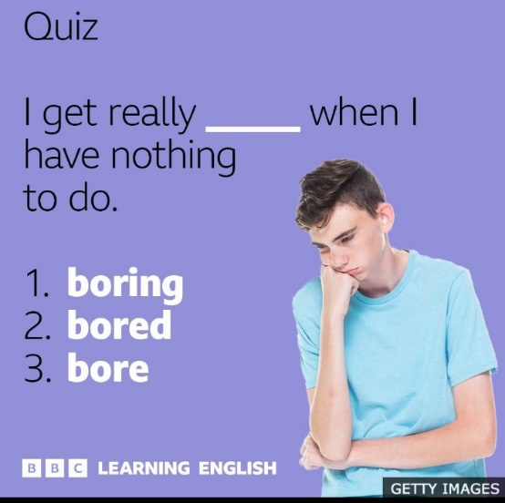  Which is the right option?  Can you make similar examples?  ………………………………………………………. | 22  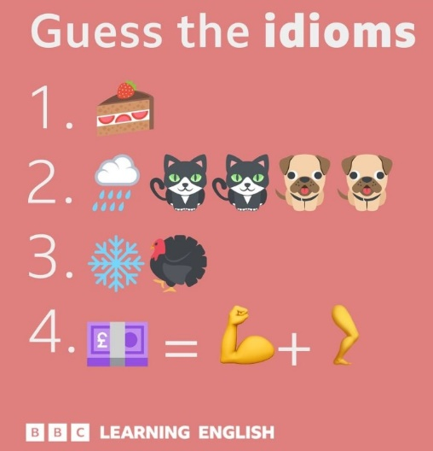  Here are some clues to some common idioms.  Can you guess what they are?  ________________________________________  ________________________________________  ________________________________________  ________________________________________  Can you use any of these in your own sentences?
23  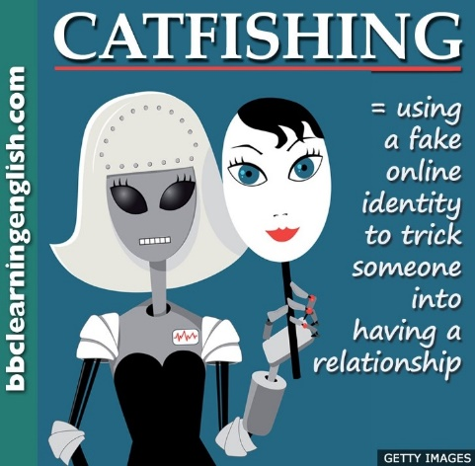  Have you heard of ‘catfishing’?  Is it good or bad?  …………………………………………….. | 24  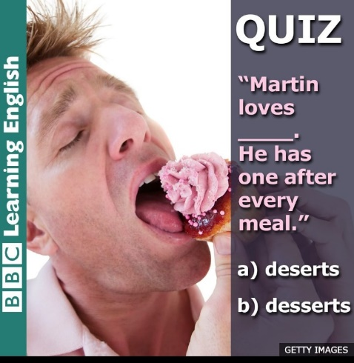  What is the correct spelling and pronunciation?  ………………………………………………….

25
https://www.instagram.com/p/CfZZUR2oP0K/
Can you explain the difference between FUN and FUNNY? ……………………………………..
Can you make your own examples? ………………………………………………………………………..
…………………………………………………………………………………………………………………………………….

26
Do you know the 3 different meanings of the verb WORK OUT? Can you make your own examples?
________________________________________
________________________________________
________________________________________
https://www.instagram.com/p/CiOrnUjpRqm/

27
Sai spiegare la differenza tra SORRY e EXCUSE ME con degli esempi?
…………………………………………………………………………………………………………………………………….

28
Sai cosa significano e come si usano le parole WANNA, GONNA, GOTTA ?
Sai fare degli esempi tuoi?
…………………………………………………………………………………………………………………………………….
…………………………………………………………………………………………………………………………………….
…………………………………………………………………………………………………………………………………….

30
https://www.instagram.com/p/Ch7gt-zjjAN/
Watch and listen to the conversation at the restaurant: do you know the difference between RECIPE and RECEIPT?
- Which one means “the directions given to prepare a dish”? ………………………………..
- Which one means “a document that proves you have paid for something”? ……….

------------------------------------------------

Optional: ONLINE TEST test your level of English: https://www.cambridgeenglish.org/test-your-english/for-schools/

